Attachment No. 4 to the Regulations of the IMAF International Polish Cup
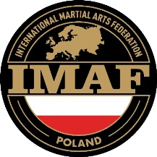
in Ju Jitsu and Kickboxing

PARENT / LEGAL GUARDIAN’S DECLARATION
(regarding a minor athlete)

Athlete’s full name:
Date of birth:
Club / Organisation:
Parent / legal guardian’s full name:
Mobile:
I, the undersigned, declare that:
- I give my consent for my child to participate in the IMAF International Polish Cup in Ju Jitsu and Kickboxing.
- My child’s health condition allows participation in sports competitions and there are no medical contraindications.
- I am aware of the risks associated with participation in combat sports, including the possibility of sustaining injuries.
- I have read the Rules and Regulations of the competition and undertake to ensure that my child complies with them.
- I consent to the processing of my child’s personal data by the Organizer for purposes related to the organization of the event.
- I consent to the free use of my child’s image (photographs, recordings) for promotional and documentary purposes related to the competition.

Date: .................................... Parent / Legal guardians’s signature: …………………............

