Attachment No. 3 to the Regulations of the IMAF International Polish Cup
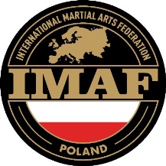
in Ju Jitsu and Kickboxing

COMPETITOR’S DECLARATION
(regarding adult athlete)

Full name:
Date of birth:
Club / Organisation:
I, the undersigned, declare that:
- I am participating in the IMAF International Polish Cup in Ju Jitsu and Kickboxing voluntarily and at my own risk and responsibility.
- My state of health allows me to take part in sports competitions and I have no medical contraindications.
- I am aware of the risks associated with participation in combat sports, including the possibility of sustaining injuries.
- I have read the Rules and Regulations of the competition and undertake to comply with them.
- I consent to the processing of my personal data by the Organizer for purposes related to the organization of the event.
- I consent to the free use of my image (photographs, recordings) for promotional and documentary purposes related to the competition.

Date: .................................... Signature: ……………………………......................

